How the executable has been produced
Once the source code was complete, it was a matter of using command prompt to run the PyInstaller module that had allowed me to compile everything into one executable file. It is stored in the project submission directory, called main.exe
Traceability to design document
Class Name | Package | Language | Class Name | Package
AccountHandler | Account | Python, SQL | AccountHandler | Account
Administrator | Account | Python, SQL | Administrator | Account
Employee | Account | Python, SQL | Employee | Account
Impl_DBConnection | Account | Python, SQL | Impl_DBConnection | Account
SQLHelper | Account | Python, SQL | SQLHelper | Account
Terminal | Account | Python, SQL | Terminal | Account
User | Account | Python, SQL | User | Account
AlertHandler | Alert | Python, SQL | AlertHandler | Alert
EmailHandler | Alert | Python, SQL | EmailHandler | Alert
Impl_DBConnection | Alert | Python, SQL | Impl_DBConnection | Alert
SQLHelper | Alert | Python, SQL | SQLHelper | Alert
I_DBConnection | Connection | Python, SQL | I_DBConnection | Connection
Impl_DBConnection | Connection | Python, SQL | Impl_DBConnection | Connection
SQLHelper | Connection | Python, SQL | SQLHelper | Connection
Impl_DBConnection | QueryPackage | Python, SQL | Impl_DBConnection | Query
QueryHandler | QueryPackage | Python, SQL | QueryHandler | Query
SQLHelper | QueryPackage | Python, SQL | SQLHelper | Query
isEmpty |  | Python, SQL | isEmpty

List of third-party software components
- SQLite-JDBC Driver
- DB Browser – Database IDE
- PyCharm – IDE
- DLLs
- Lib
Note that there are many more external libraries but can’t be listed as there are simply too much. The project submission includes all files in the form of a directory tree, including the external libraries, however as it’s already been compiled, there won’t be the need for any prerequisites. This is solely for maintenance work purposes only.
Testing Plan
Use Case ID: 1 |  | Use Case Name: Create Query (Save and Run in collateral)
Test Number: 1
Objective: Test run and save path
Setup: Existing user creates a new query to look at the daily cost for Cegid from the start of the month and saves & runs it.
Expected result: Table showing this information should be returned, with query stored
Test:
- Enters 1 to create query
- Resources listed out
- Chooses Cegid (5)
- Timeframe options
- Chooses Month to date (2)
- Granularity options
- Chooses daily (1)
- Chooses to save and run the query (3)
Test record: All parts run successfully
Date: 25 June 2022 | Tester: Aman Messinezis
Result: Listed out costs by day since the start of the month, with saved query in database
Use Case ID: 2 |  | Use Case Name: Log in
Test Number: 1
Objective: Log in with correct details
Setup: Log in with already existing user details
Expected result: Taken to dashboard
Test:
- Chooses login option
- Username entered
- Password entered
- Taken to dashboard
Test record: All parts run successfully
Date: 25 June 2022 | Tester: Aman Messinezis
Result: Dashboard displayed

Use Case ID: 2 |  | Use Case Name: Create Query
Test Number: 2
Objective: Enter incorrect details twice
Setup: Wrong user details entered
Expected result: Prompted to try again as details are incorrect
Test:
- Enters username
- Enters password
- Told to try again
- Repeat first two steps
- Told to try again
Test record: All parts run successfully
Date: 25 June 2022 | Tester: Aman Messinezis
Result: Asked to try again

System Testing could work by having prebuilt parameters for different users, size 50 as that’ll be the soon to be size of Capacitas, with different activity profiles, with more frequent ones being more likely to be made like creating a new query. Should time how long it takes for API requests to be made and track time for times where a connection to the database has to be made to see if multiple users using the application will cause an impact on handling the requests
The following table shows the probability of a use case being used after 3 months
Use Case | Probability (%)
Delete Account | 1
Forgot Password | 5
Login | 10
Logout | 10
Create Account | 5
Create Query | 7
Save New Query | 5
Open Query | 1
Change Query | 2.5
Remove Query | 4
Run Query | 8
Setup Alert | 5
Change Alert | 3
Remove Alert | 3.5
Open Alert | 1
Save New Alert | 5
Disconnect from Database | 4
Disconnect from Azure | 4
Connect to Azure | 4
Connect to Database | 4
Send Email | 8

The main purpose of this program is to get cost information from clients that are in the form of resource groups, and as this is usually done monthly for invoice purposes, alerts will be generated at around the same time, which required the running of queries. Signing in and out will be of the highest probability as all use cases first require the need to having to sign in and signing out once complete. Other use cases that aren’t explicitly called by the user will still be used frequently like connecting to Azure services.
Parameters will be populated by using a code tree, entering the right inputs. Outputs will be between a range for each input provided. If the output falls within range, pass, else, fail
Results recorded on table with all important metrics which include but not limited to time until execution complete either fail or success and if failed or success and the inputs passed
Non-Functional Testing
Scalability – Slowly increase the number of users using the application to keep track on response times with different queries and noticing slow behaviour to then work on said areas to improve the system.
Security – Hire a hacker to try get information from the application who will work for an hour and see what he gets. Any flaws found should be the first order of business especially when user data is at risk
Reliability – One user making several activities for 10 minutes. Keep track on which use cases need working on by seeing if actual results do not meet the expected result

Component Diagram
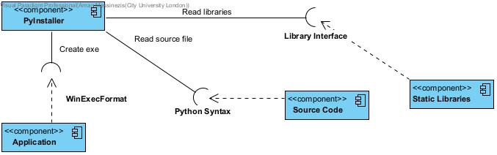

Deployment Diagram
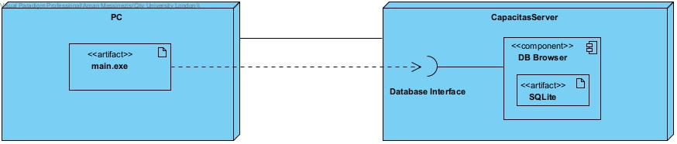

Problems and Solutions
Problem | Solution
Microsoft API Documentation was very difficult to understand as different pages and links were difficult to find | After looking for a week, I came across a Microsoft Azure SDK with necessary libraries and modules necessary for the project
Realised that I couldn’t complete all use cases in time for submission | Worked on completing high priority ones first and if there was available time, work on less prioritised use cases
Compiled file wasn’t connecting to database | Realised it was a matter of altering file path which required recompiling the application

